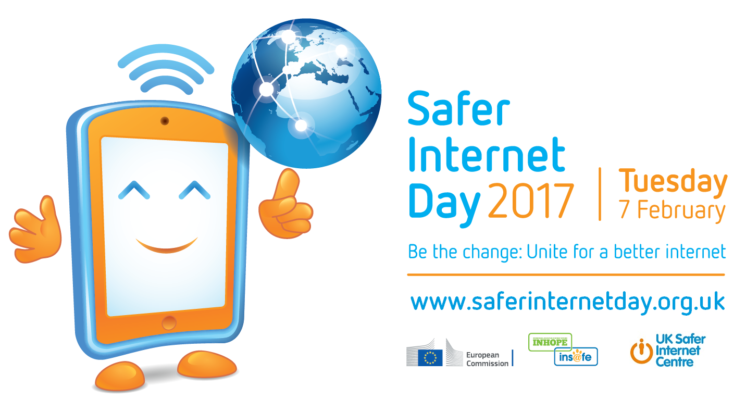

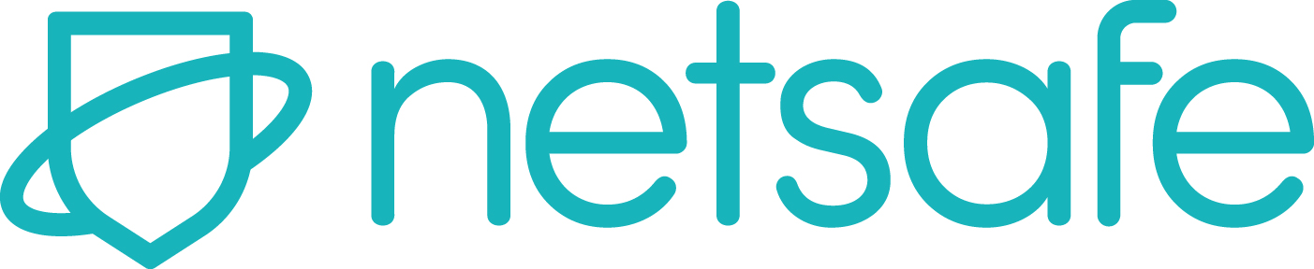

Safer Internet Day 2017 Story

Safer Internet Day is here

Today is Safer Internet Day. Celebrated globally each year on 7 February, Safer Internet Day promotes the safe and positive use of digital technology. Coordinated in New Zealand by Netsafe, today is an opportunity for everyone to learn about the things we can do to stay safe online.

Why should you care about Safer Internet Day?
Eight out of ten people in New Zealand now own a smartphone or tablet, and 88% use social media every month. The internet is a great tool that has changed the way we interact with the world. It’s changed the way we share ideas, buy and sell, learn new things and meet new people. We’re more connected than ever. This brings opportunities – and some challenges.

Why and how to get involve
Did you know that 10% of adults in New Zealand have experienced harmful speech on the internet? Online challenges affect everybody and having the knowledge to make the right decisions is the first step to creating a better internet.

For Safer Internet Day 2017 Netsafe has created a staying safe online guide to make staying safe online easier for everybody. The guide is full of helpful advice, tips and how-to guides from some of the biggest names in tech like Google, YouTube, Twitter, and Trade Me.

Read through the advice and make sure you share it with your friends, family and whanau on social media or by printing it out.

You can find the full guide here and read advice from the guide about passwords below.

Power up your passwords
One of the easiest ways you can protect yourself online is by using strong passwords. Think of online passwords as the key that unlocks a vault of private information about you. Keep your information locked away safely using these tips.

- Make your password at least 15 characters’ long
- Use a phrase instead of a word
- Use a different password for each account
- Try using lyrics from a song you’ll remember
- Don’t use your name, your kids or your pets name
- Change your password every three months

Find the full staying safe online guide netsafe.org.nz/staying-safe-online

About Netsafe
Netsafe is a not for profit organisation that focuses on online safety. They offer support, advice and education to everyone in New Zealand to help minimise online risks. Whether you’re dealing with online bullying, an online request that looks suspicious, or you just want advice for family members using the internet they can help.

Follow Netsafe on Facebook and Twitter to keep up to date with Safer Internet Day 2017 and the latest in online safety news, advice, tips and information.

Safer Internet Day 2017 Blurb

7 February is Safer Internet Day. Did you know that 10% of adults in New Zealand have experienced harmful speech on the internet? Netsafe has published a guide full of advice to help you and your family stay safe online. It’s full of tips from Google, Trade Me and more. Find the guide at netsafe.org.nz/staying-safe-online

