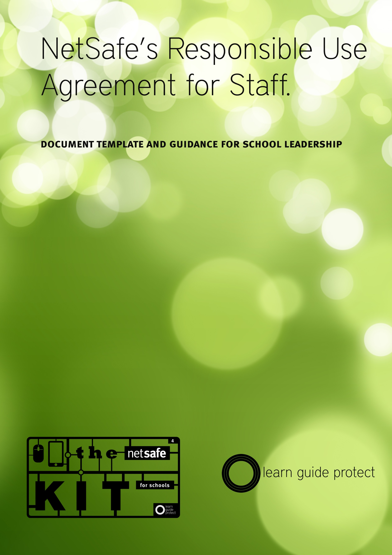
NetSafe Responsible Use Agreement for Staff
Introduction to the Responsible Use Agreement
The National Administration Guideline 5 (NAG 5) charges schools with the responsibility for providing students with a safe emotional environment. Schools also have a responsibility to prepare students for the future. This includes preparing young people to seize the opportunities offered by new technologies and be effective and responsible users of communication tools.

Through our Kit for Schools we are suggesting a Digital Citizenship based model for schools fundamentally different from a traditional approach to internet safety where teachers and administrators prevent access to specific content, to a model where students build skill and knowledge to effectively manage challenge online themselves. This model focuses on increasing learner preparation, while reducing external protection.

We refer to this model as “Learn: Guide:Protect” which clearly delineates the approaches required to support the development of digital citizenship in our young people. The values and skills they are able to “LEARN”, the support they are given in this process by skilled “GUIDES” and the shaping of the environment around them which ensures they are “PROTECTED” while they develop the required attributes to be a successful digital citizen.

A cornerstone of the traditional approach was the production of “Acceptable Use Agreements” which were often characterised by detailing of prohibited behaviours and activities. The shift in model that focuses on increased preparation rather than protection, then logically lends itself to a different approach in terms of use agreements, from prohibited behaviours to increased individual responsibility and accountability. In other words, a “Responsible Use Agreement.”

How to Use this Document
This Staff Responsible Use Agreement template is designed to be used in concert with our Digital Citizenship Policy template and our Student Responsible Use Agreement Template.

This document consists of a use agreement framework, populated by a series of “fragments” which schools can use, edit or delete to suit their needs. Designed to reflect the varying requirements of teachers, students and the wider school community in every school, it is expected that schools will adapt this template to produce the best fit for their environment after consultation with the appropriate groups.

It is expected that a document such as this should be reviewed and signed on a yearly basis. Both the school and the signatory should keep a copy of this document on file.

It is our belief that the development of a digital citizenship philosophy is a task for the whole community. Consultation and co-creation of documents such as these is a useful step in that process and one that will benefit all members of the community into the future.

These documents are deliberately supplied in a “No Frills” format, and shared under a Creative Commons Attribution-NonCommercial-ShareAlike 3.0 New Zealand (CC BY-NC-SA 3.0) license to encourage schools to adapt them to their specific needs.
Responsible Use Agreement <template>

Introduction
[our school] believes in a Digital Citizenship model for supporting safe and responsible use of the internet in a teaching and learning context. A vital part of fostering this culture is the support that is provided to students in their learning by the “Guides” around them. One of the most important parts of this guidance is the modelling of good digital citizenship skills that young people observe in their day to day interactions.

[our school] defines a successful digital citizen as an individual who;
- is a confident and capable user of ICT
- uses technologies to participate in educational, cultural, and economic activities
- uses and develops critical thinking skills in cyberspace
- is literate in the language, symbols, and texts of digital technologies
- is aware of ICT challenges and can manage them effectively
- uses ICT to relate to others in positive, meaningful ways
- demonstrates honesty and integrity in their use of ICT
- respects the concepts of privacy and freedom of speech in a digital world
- contributes and actively promotes the values of digital citizenship

You can read more about Digital Citizenship in schools here

In line with this belief, we ask all staff, students and volunteers to commit to using the internet and associated technologies in a safe and responsible manner by accepting a Responsible Use Agreement.

Access to the ICT services provided by the school may be withdrawn if a responsible use agreement is not signed.

Guidelines for Responsible Use
The school provides access to the internet and associated technologies because it believes in the benefits that they bring to the teaching and learning process. It is expected that they will be used to benefit staff and students, but it is also understood that they may be used to engage in personal activities. All activity must be appropriate to the school environment. This applies to school owned ICT devices used inside or outside of school, and personally owned ICT devices used inside school and during school activities.

Your user accounts is provided exclusively for your use. You are responsible for all the activity that is associated with your account. Please don’t share your account details with anyone. To help maintain the security of your account please use a strong password. If you suspect that your account details are known by someone else, then please let the school know.

In all use of ICT devices it is important to relate to others positively, to avoid engaging in harassing or harmful communications, to respect other peoples freedom of speech and uphold their right to privacy.

The principles of confidentiality and privacy extend to accessing, inadvertently viewing or disclosing information about staff, or students and their families, stored on the school network.

Teachers should bear in mind that professional and ethical obligations are as applicable to activity online as they are to their daily interactions with students and the community in and out of school. The Teachers Council Code of Ethics provides a useful framework for decision making around what is and is not responsible, ethical conduct.

It is every individual's responsibility to ensure that when using ICT their actions are within the law. This includes research, communications, use of social media, file sharing and any other activity carried out in the context of teaching and learning.

Everyone at [our school] must comply with New Zealand copyright law as laid out in the Copyright Act 1994. Some parts of the law such as the Infringing File Sharing Amendment 2011 make the school accountable for copyright infringements recorded as taking place using the school internet connection. The school may pass on any costs associated with copyright infringement to those responsible.

All ICT equipment should be used with care. If you need to install hardware or software and are unsure of how to do so, or are concerned about the effects that this may have, then check with the school before you do. If you know that equipment has been damaged, lost or stolen, please report it as soon as you can.

Our schools believes in the importance of developing confident and capable users of ICT. If you are unsure of anything regarding the use of ICT in teaching and learning, you should discuss this with your manager, or a member of the school leadership team.

Our school has a policy and procedures around digital citizenship and internet safety. You should familiarise yourself with them. They will give you an idea about our school and our communities values relating to digital citizenship, and also provide support for you in terms of dealing with any challenges you may experience when using ICT. If you are unsure or uncomfortable with any part of these documents you should discuss it with a member of the school leadership team.

Should a situation arise that you feel may constitute a breach of this agreement, either accidental or deliberate, please notify a member of the school leadership team as quickly as possible. Make a detailed note of the incident including time, date, the names of those involved, any devices involved and your summary of the situation.

Responsibilities of the School
In the interest of maintaining a safe environment, the school reserves the right to conduct an audit of its computer network, internet access facilities, computers and other school ICT equipment. This may include any stored content, and all aspects of its use, including email. An audit may include any device provided by or subsidised by/through the school or provided /subsidised by the Ministry of Education. For this purpose, any electronic data or files created or modified on behalf of the school on any ICT device, regardless of who owns it, is the property of the school.

The school may monitor traffic and material sent and received using the school’s ICT infrastructures.

[our school] believes that ICT is an integral part of teaching and learning, but is aware that when using it we may experience challenges from time to time. To this end the school may deploy filtering and/or monitoring software where appropriate to restrict access to certain sites and data. Filtering should enhance the teaching and learning process rather than restrict it. In situations where this is not the case, you should inform the school rather than attempting to circumvent filtering or monitoring systems.

Your Responsibility as a Digital Citizenship Guide
The guidance that young people receive in their development of digital citizenship skills is of the utmost importance. The success of their learning is greatly enhanced by the increased capability of the guides around them. As a critical component in this process for learners it is important that you understand what makes a successful guide.

- As a guide you should be knowledgeable about the technology that young people are using to enable you to discuss the way in which it is used, and the challenges experienced.
- You should be aware of opportunities presented by technology in terms of its use in education, but also its use in other aspect of society including its social application.
- You should be aware of challenges that exist around the technology. This means understanding the challenges, as they exist in the lives of young digital citizens.
- You should act as a consistent and positive role model for responsible activity online
- You should be confident in your ability to make value judgements about challenge and opportunity for learners.

As a guide, you should discuss your own experiences as a digital citizen and share your strategies for managing challenge with students. However, it is vital that you recognise the importance of consistent, positive role modeling in all of your use of technology in a teaching and learning context.

As part of our commitment to our digital citizenship philosophy, the school will provide you with support in your role as a digital citizenship guide. If you require support at any time, please discuss it with a member of the school leadership team.
Breaches of this Agreement
A breach of this agreement may constitute a breach of discipline and may result in a finding of serious misconduct. A serious breach of discipline would include involvement with objectionable material, activities such as abuse or harassment or misuse of the school ICT in a manner that could be harmful to the safety of staff or students, or call into question the user’s suitability to be in a school environment.

If there is a suspected breach of this agreement involving privately-owned ICT on the school site or at a school-related activity, the matter may be investigated by the school. The school may request permission to audit that equipment/device(s) as part of its investigation.

In addition to any inquiry undertaken by the school itself, it may be necessary to notify an applicable law enforcement agency at the commencement, during or after our investigation.

Declaration
I have read and am aware of the obligations and responsibilities outlined in this Responsible Use Agreement document, a copy of which I have been advised to retain for reference. These responsibilities and guidelines relate to the safety of myself, students, the school community and the school environment.

I also understand that breaches of this Use Agreement may be investigated and could result in disciplinary action or referral to a law enforcement agency.

Name:
Signature
Date

Please note that conducting an audit does not give any representative of [Every School] the right to enter the home of school personnel, nor the right to seize or search any ICT equipment/devices belonging to that person

