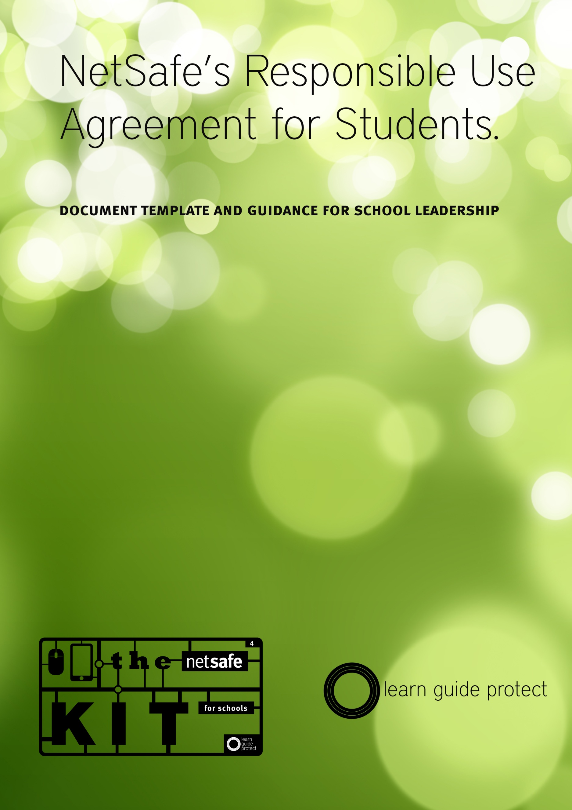
NetSafe’s Responsible Use Agreement for Students
Introduction to the Responsible Use Agreement
Technological and environmental changes mean that the concept of internet safety has fundamentally changed in a short passage of time. NetSafe last released a use agreement template in 2007, to a school landscape largely untouched by social media, blogs or tweets. Few would deny that the effects these technologies have had, and continue to have are transformational. These transformations, driven by positive effects on teaching and learning mean that internet safety now plays a direct role in the practices of a digitally literate population. As more people and organisations conduct learning, commerce, relationships, and civic activities on the internet, they need to be confident that they are safe and secure in these practices. Internet safety has moved from protecting people and organisations to giving people the skills, knowledge and confidence to maximise opportunity online.

This new environment can allow for increased and higher participatory use of technology in education. Students and teachers are, and will be, increasingly immersed in an ultra-fast participatory web experience. In this highly fluid environment, the effectiveness of technological and policy measures that schools have previously relied on to protect users from risk is decreasing. Attention must therefore shift to increasing the capability of young people as participants in a digital society or ‘digital citizens’, and the capability of teachers as guides of the digital society.

Through our Kit for School we are suggesting a Digital Citizenship based model for schools fundamentally different from a traditional approach to internet safety, from one where teachers and administrators prevent access to specific content, to a model where students build skill and knowledge to effectively manage challenge online themselves. This model focuses on increasing learner preparation, while reducing external protection.
A cornerstone of the traditional approach was the production of “Acceptable Use Agreements” which were often characterised by detailing of prohibited behaviours and activities. The shift in model that focuses on increased preparation rather than protection then logically lends itself to a different approach in terms of use agreements, from prohibited behaviours to increased individual responsibility and accountability. In other words, a “Responsible Use Agreement.”

How to Use this Document
This Student Responsible Use Agreement template is designed to be used in concert with our Digital Citizenship Policy template and our Staff Responsible Use Agreement Template.

This document consist of a use agreement framework, populated by a series of “fragments” which schools can use, edit or delete to suit their needs. Designed to reflect the varying requirements of teachers, students and the wider school community in every school, it is expected that schools will adapt this template to produce the best fit for their environment after consultation with the appropriate groups.

There are three different Student Responsible Use Agreement templates provided. Templates 1 and 2 have no sections for Student signatures; template 3 is simply a copy of template 1 with a space for students to sign to reflect their understanding and agreement.

While it is expected that students at secondary school level would be able to sign the document, NetSafe recommends that students at primary and intermediate level are not asked to do so themselves, any only parents signatures being required. This decision however will ultimately rest with school boards and school management teams.

Template 2 has blank text boxes included after each of the Digital Citizenship criteria. These are intended to be used by students, working in class or at home to define what each of the digital citizenship themes means in practice for them. This will hopefully both re-enforce what responsible use means for the students, but also provide teachers and parents with some insight into how young people view the challenges they face using the internet and associated technologies, and how they currently manage them.

It is expected that a document such as this should be reviewed and signed on a yearly basis. Both the school and the signatory should keep a copy of this document on file.

It is our belief that the development of a digital citizenship philosophy is a task for the whole community. Consultation and co-creation on documents such as these is a useful step in that process and one that will benefit all members of the community into the future.

These documents are deliberately supplied in a “No Frills” format, and shared under a Creative Commons Attribution-NonCommercial-ShareAlike 3.0 New Zealand (CC BY-NC-SA 3.0) license to encourage schools to adapt them to their specific needs.
Responsible use agreement <template all>

Introduction
[Our school] believes in a Digital Citizenship model for supporting safe and responsible use of the internet in teaching and learning. An important part of this is that we are able to show others what that responsible use looks like while we are using technology in our learning.

We think a good digital citizen is someone who;
- is a confident and capable user of ICT
- will use ICT for learning as well as other activities
- will think carefully about whether the information they see online is true
- will be able to speak the language of digital technologies
- understands that they may experience problems when using technology but can deal with them
- will always use ICT to communicate with others in positive ways
- will be honest and fair in all of their actions using ICT
- will always respect people’s privacy and freedom of speech online
- will help other to become a better digital citizen

Because we know this is important for us all, we ask everyone, the staff, students and volunteers working at the school to agree to use the internet and other technologies in a safe and responsible way by following the rules laid out in a Responsible Use Agreement like this one.

If someone cannot agree to act responsibly, or the things that they do mean that other people are being harmed, then we might stop them from using the internet or other technology at school.
Responsible Use Agreement <template 1>
When using information & communications technologies (ICT) at [my school] I will always be a good digital citizen. This means that I;

Will be a confident and capable user of ICT.
I know what I do and do not understand about the technologies that I use. I will get help where I need it.

will use ICT for learning as well as other activities.
I understand that technology can help me to learn. I also know it can also be used to talk to people, to buy and sell things and to have my opinion heard. I know when and where it is OK to do each one.

will think carefully about whether the information I see online is true.
I know that it is easy to put information online. This means that what I see is not always right. I will always check to make sure information is real before I use it.

will be able to speak the language of digital technologies.
When people talk online the things they say can be quite different from a conversation they might have if they were sitting next to each other. I know that I must try to understand what people are saying before I react to them. If I am not sure, I can ask them or someone else to explain.

understand that I may experience problems when I use technology but that I will learn to deal with them.
I understand that there will be times when technology may not work as I expected it to, or that people may be mean or unkind to me online. When these things happen, I know that there are ways I can deal with it. I also know there are people I can go to, to get help if I don’t know what to do next.

will always use ICT to communicate with others in positive, meaningful ways.
I will always talk politely and with respect to people online. I know that it is possible to bully or hurt people with what I say and do on the internet. I will think about the effect that my actions have on other people.

will be honest and fair in all of my actions using ICT.
I will never do anything online that I know will hurt anyone. I will make sure what I do is not against the law. I will make sure that my actions don’t break the rules of the websites that I use. When I am not sure about what I am doing I will ask for help.

Will always respect people’s privacy and freedom of speech online.
I understand that some information is private. I will be careful when using full names, birthdays, addresses and photos of other people and of my own. I also know that I will not always agree with what people say online but that does not mean that I can stop them or use it as an excuse to be unkind to them.

will help other to become a better digital citizen.
Being a good digital citizen is something that we all have to work at. If I know that my friends are having problems online, I will try to help them. If I see that someone is being unfairly treated online then I will speak up rather than just watch it happen.
Responsible Use Agreement <template 2>
When using information & communications technologies (ICT) at [my school] I will always be a good digital citizen. This means that I;

1. Will be a confident and capable user of ICT.
I know what I do and do not understand about the technologies that I use. I will get help where I need it.
This means I will...
1.
2.
3.

2. Will use ICT for learning as well as other activities.
I understand that technology can help me to learn. I also know it can also be used to talk to people, to buy and sell things and to have my opinion heard. I know when and where it is OK to do each one.
This means I will...
1.
2.
3.

3. Will think carefully about whether the information I see online is true.
I know that it is easy to put information online. This means that what I see is not always right. I will always check to make sure information is real before I use it.
This means I will...
1.
2.
3.

4. Will be able to speak the language of digital technologies.
When people talk online the things they say can be quite different from a conversation they might have if they were sitting next to each other. I know that I must try to understand what people are saying before I react to them. If I am not sure, I can ask them or someone else to explain.
This means I will...
1.
2.
3.

5. Understand that I may experience problems when I use technology but that I will learn to deal with them.
I understand that there will be times when technology may not work as I expected it to, or that people may be mean or unkind to me online. When these things happen, I know that there are ways I can deal with it. I also know there are people I can go to, to get help if I don’t know what to do next.

This means I will...
1.
2.
3.

6. Will always use ICT to communicate with others in positive, meaningful ways.
I will always talk politely and with respect to people online. I know that it is possible to bully or hurt people with what I say and do on the internet. I will think about the effect that my actions have on other people.
This means I will...
1.
2.
3.

7. Will be honest and fair in all of my actions using ICT.
I will never do anything online that I know will hurt anyone. I will make sure what I do is not against the law. I will make sure that my actions don’t break the rules of the websites that I use. When I am not sure about what I am doing I will ask for help.
This means I will...
1.
2.
3.

8. Will always respect people’s privacy and freedom of speech online.
I understand that some information is private. I will be careful when using full names, birthdays, addresses and photos of other people and of my own. I also know that I will not always agree with what people say online but that does not mean that I can stop them or use it as an excuse to be unkind to them.

This means I will...
1.
2.
3.

9. Will help other to become a better digital citizen.
Being a good digital citizen is something that we all have to work at. If I know that my friends are having problems online, I will try to help them. If I see that someone is being unfairly treated online then I will speak up rather than just watch it happen.
This means I will...
1.
2.
3.

Responsible Use Agreement <template 3>
When using information & communications technologies (ICT) at [my school] I will always be a good digital citizen. This means that I;

Will be a confident and capable user of ICT.
I know what I do and do not understand about the technologies that I use. I will get help where I need it.

Will use ICT for learning as well as other activities.
I understand that technology can help me to learn. I also know it can also be used to talk to people, to buy and sell things and to have my opinion heard. I know when and where it is OK to do each one.

Will think carefully about whether the information I see online is true.
I know that it is easy to put information online. This means that what I see is not always right. I will always check to make sure information is real before I use it.

will be able to speak the language of digital technologies.
When people talk online the things they say can be quite different from a conversation they might have if they were sitting next to each other. I know that I must try to understand what people are saying before I react to them. If I am not sure, I can ask them or someone else to explain.

Understand that I may experience problems when I use technology but that I will learn to deal with them.
I understand that there will be times when technology may not work as I expected it to, or that people may be mean or unkind to me online. When these things happen, I know that there are ways I can deal with it. I also know there are people I can go to, to get help if I don’t know what to do next.

Will always use ICT to communicate with others in positive, meaningful ways.
I will always talk politely and with respect to people online. I know that it is possible to bully or hurt people with what I say and do on the internet. I will think about the effect that my actions have on other people.

Will be honest and fair in all of my actions using ICT.
I will never do anything online that I know will hurt anyone. I will make sure what I do is not against the law. I will make sure that my actions don’t break the rules of the websites that I use. When I am not sure about what I am doing I will ask for help.

Will always respect people’s privacy and freedom of speech online.
I understand that some information is private. I will be careful when using full names, birthdays, addresses and photos of other people and of my own. I also know that I will not always agree with what people say online but that does not mean that I can stop them or use it as an excuse to be unkind to them.

Will help other to become a better digital citizen.
Being a good digital citizen is something that we all have to work at. If I know that my friends are having problems online, I will try to help them. If I see that someone is being unfairly treated online then I will speak up rather than just watch it happen.

Student Declaration
I understand that these guidelines for responsible use are to be followed when using any technology whilst at school or whilst on any school activity. I am aware that this may include the use of a device that the school does not own.

I understand that if I breach this responsible use agreement, I may lose access to school ICT services including the use of the internet, on school owned devices or any personally owned device used at school.

Parent Declaration <template all>
Signed ………………………………………………………………………………………………….
Name ………………………………………………………………………………………………….
Date ………. /……../………

I understand that our school is supporting students as they learn the skills required to become successful digital citizens. Our school defines a digital citizen as someone who;
- is a confident and capable user of ICT
- uses technologies to participate in educational, cultural, and economic activities
- uses and develops critical thinking skills in cyberspace
- is literate in the language, symbols, and texts of digital technologies
- is aware of ICT challenges and can manage them effectively
- uses ICT to relate to others in positive, meaningful ways
- demonstrates honesty and integrity in their use of ICT
- respects the concepts of privacy and freedom of speech in a digital world
- contributes and actively promotes the values of digital citizenship

I understand that our school has a policy and associated procedures* which outlines the schools digital citizenship approach and how this supports teaching and learning.
*These documents are available [on the school website/ on request/ at the school office]

I understand that the school provides access to the internet and other communications technologies because it believes that they enhance the teaching and learning process.

I understand that the school encourages responsible behaviour by students when using technology to help protect themselves and each other from experiencing harm online. I am aware that this “Responsible Use Agreement” is part of that, and that it encourages students to consider how their actions can affect themselves and those around them.

I have read the student declaration and have talked with my child about what it means to them. I am happy that my child understands what this means, and that they are capable of working within the guidelines.

I am aware that students can experience challenges when using technology, but that the school makes every effort to support students to manage those challenges effectively. I understand that by learning to deal with them in a safe environment with the appropriate support they will be better prepared to deal with those challenges in the future.

If I have questions or concerns about the way in which technology is being used by my child at school, I know the school is happy to discuss this with me, and I am aware that I am welcome to do this at any time.
Signed ………………………………………………………………………………………………….
Name ………………………………………………………………………………………………….
Parent of ………………………………………………………………………………………………
Date ………./……../………

