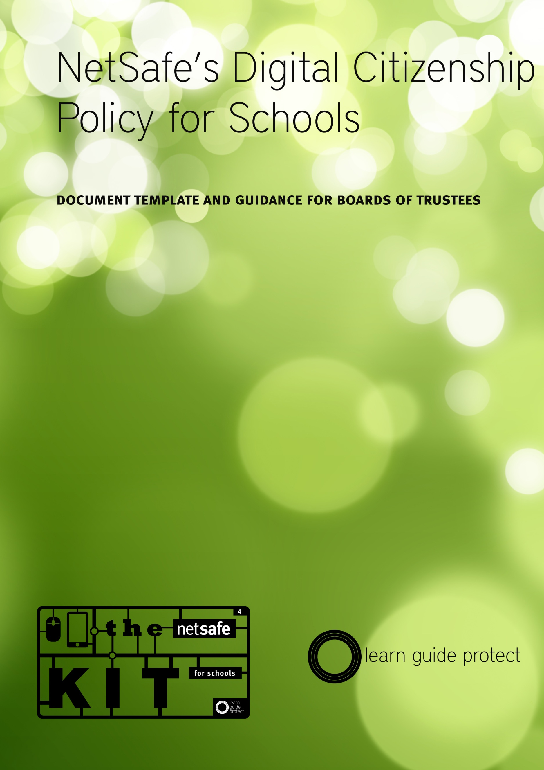
Notes for Boards on creating a Digital Citizenship Policy.
Sustained technological and environmental changes mean that the concept of internet safety has fundamentally shifted since NetSafe last released a policy template. It has become clear that safety is no longer an exercise in protecting people from dangers online or reducing reputational risk for organisations like schools providing ICT services. Changes in the technology landscape mean that internet safety now plays a direct role in the practices of a digitally literate population. As more people and organisations conduct learning, commerce, relationships, and civic activities on the internet, they need to be confident that they are safe and secure in these practices. Internet safety has moved from protecting people and organisations to giving people the skills, knowledge and confidence to maximise opportunity online.

While boards have a role in guardianship and governance, schools have an obligation to provide students with the tools they require to function effectively in a digitally literate society. It is our belief that by supporting students to develop as successful digital citizens, schools are providing the best framework for learning the values, behaviours and skills required to contribute meaningfully in an increasingly online world while ensuring students have the knowledge and ability to successfully manage the inevitable challenges of the internet.

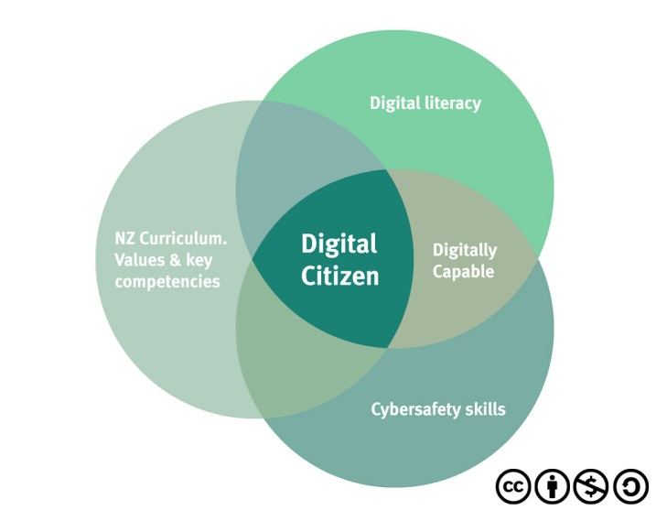
Digital Citizenship in New Zealand Schools.

NetSafe’s model for defining digital citizenship recognises the importance of cybersafety skills, digital literacy and the Values & Key Competencies of the National Curriculum when building a model for supporting digital citizenship development in schools

Drawing from the Key Competencies and Values in the NZ Curriculum and the growing body of research knowledge, NetSafe has produced this definition of a New Zealand Digital Citizen:

- is a confident and capable user of ICT
- uses technologies to participate in educational, cultural, and economic activities
- uses and develops critical thinking skills in cyberspace
- is literate in the language, symbols, and texts of digital technologies
- is aware of ICT challenges and can manage them effectively
- uses ICT to relate to others in positive, meaningful ways
- demonstrates honesty and integrity in their use of ICT
- respects the concepts of privacy and freedom of speech in a digital world
- contributes and actively promotes the values of digital citizenship

Using the Digital Citizenship Policy Template
NetSafe is well aware that every school environment is different. Students, teachers, parents and the wider community each have very different needs. To this end, NetSafe has provided a series of “fragments” that the board can assemble into a complete policy, or use to add to an existing policy, in order to fit the needs of your school environment.

The fragments are in two sections Rationale, and Policy. It is expected that there will be procedures developed to support this policy, and notes have been provided to give boards and school leaders some guidance as to what they may include.

It is expected that boards will consult with the school community in the establishment of a policy such as this. We believe that community support is a vital component of the development of a Digital Citizenship approach to the use of technology in the teaching and learning process.

NetSafe has condensed its understanding of how schools and boards can support a digital citizenship culture, into its Kit for Schools which can be found at www.netsafe.org.nz/the-kit . This is available to all schools free of charge. Boards can also access background information on digital citizenship in our whitepaper Digital Citizenship in New Zealand Schools

It is our hope that the establishment of a policy such as this can be a useful starting point for discussions between teachers, students, parents and the wider community that will eventually lead to greater understanding of what role technology can play in not only the teaching and learning process, but also in our wider community now, and into the future.

These documents are deliberately supplied in a “No Frills” format, and shared under a Creative Commons Attribution-NonCommercial-ShareAlike 3.0 New Zealand (CC BY-NC-SA 3.0) license to encourage schools to adapt them to their specific needs.

Digital Citizenship Policy Template

Rationale
{every school} supports a Digital Citizenship model for the promotion of safe and responsible use of technology.

The board recognises that by fostering a culture of successful digital citizenship in our students, staff and our wider community we are encouraging everyone to take responsibility for themselves and others in their use of ICTs. This allows us to harness the potential that technology brings to the teaching and learning process, while minimising and learning to effectively respond to the challenges we may experience while using them in a learning context.

The board is aware that preparing our students to make effective use of ICTs is an important part of their preparation for participation and contribution in society today and into the future.

It is our belief that we must prepare our students to actively participate in the world in which they live. It is clear that a key skill in this new world will be their ability to participate as effective digital citizens. An important part of learning these skills is being given the chance to experience the opportunities, and the challenges presented by technology in a safe, secure and nurturing environment, where clear, effective guidance can be sought as students and teachers learn.

The board recognises that its obligations under the National Administration Guidelines extend to use of the internet and related technologies.

Policy

{every school} will develop and maintain procedures around the safe and responsible use of the internet and related technologies (ICTs). These internet safety procedures will recognise the value of the technology and encourage its use in a teaching and learning context while helping to minimise and manage the challenges that may be experienced by students, teachers and the wider school community.

The school will consult with parents and the wider school community, as to how it intends to use ICT and where possible explain how it benefits the teaching and learning process.

These procedures will aim to not only maintain a safer school environment, but also aim to address the need of students and other members of the school community to receive education about the safe and responsible use of information and communication technologies.

Date policy adopted by the Board:………………………………………………………………………………
Chairperson: ……………………………………………………………………………….

Date for review: ……………………………………………………………………………….

Notes for the establishment of procedures associated with these policy statements.
The NetSafe Kit for Schools (www.netsafe.org.nz/the-kit/) contains a wide range of information on how to establish a safe school environment based upon a digital citizenship model. It provides a good starting point for schools looking at establishing or updating their policies regarding internet safety, as well as their use agreements and their teaching programme around internet safety and digital citizenship.

NetSafe encourages schools to make use agreements a part of its approach to maintaining a safe environment. Use agreements should cover board members, all board employees, students and all other individuals authorised to use the schools internet facilities or other ICT devices. Access to these facilities should be reliant upon signing the use agreement.
Signing of use agreements by students is an issue which raises concern for some. NetSafe advises that ONLY parents signatures should be sought for Primary and Intermediate school students, with student AND Parent signatures on agreements for Secondary school students. Further information can be found in the NetSafe Kit for Schools.

Schools have the right to monitor, access and review all use of their internet facilities and ICT equipment. Schools may carry out an audit of equipment owned or leased by the school at any time.

Schools are also able to request permission to audit privately owned equipment used at the school or in the course of school activity. Increasing use of personally owned ICT devices (sometimes referred to as BYOD or Bring Your Own Device schemes) may lead to separate agreements for use or contracts surrounding their use in schools. Schools should ensure that these agreements do not contradict any agreements around digital citizenship or internet safety currently in use in the school.

Schools should develop procedures around the collection, use and storage of confidential information. This includes student and staff biographical data, student images and student produced work. Schools are subject to the provisions of the Privacy Act 1993. Schools should make policy and procedure around these issues. This could include production of a creative commons policy to cover work produced at the school and seeking “permissions for use” of student work and/or images.

While technology is provided to enhance the teaching and learning process, it is inevitable that at times there will be breaches of responsible use. The response to individual incidents must follow clearly laid out procedures, which are developed and reviewed as part of the board and senior management teams regular review cycle. If schools are unclear about how to respond to a particular incident then they should seek advice from NetSafe, from legal counsel, professional bodies such as The Teachers Council, or from law enforcement agencies. NetSafe can assist schools in locating the correct agency to talk to in specific circumstances.

http://www.netsafe.org.nz/Doc_Library/Digital_Citizenship_in_New_Zealand_Schools_Overview.pdf

